**Q.write a program to find greater num b/w two numbers and check a given grade is valid or not?**

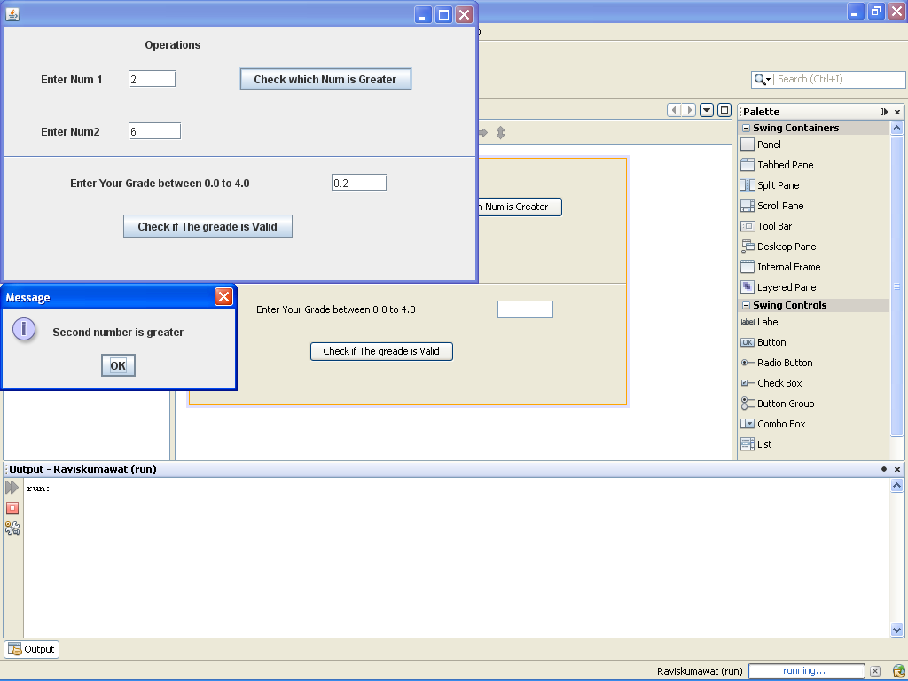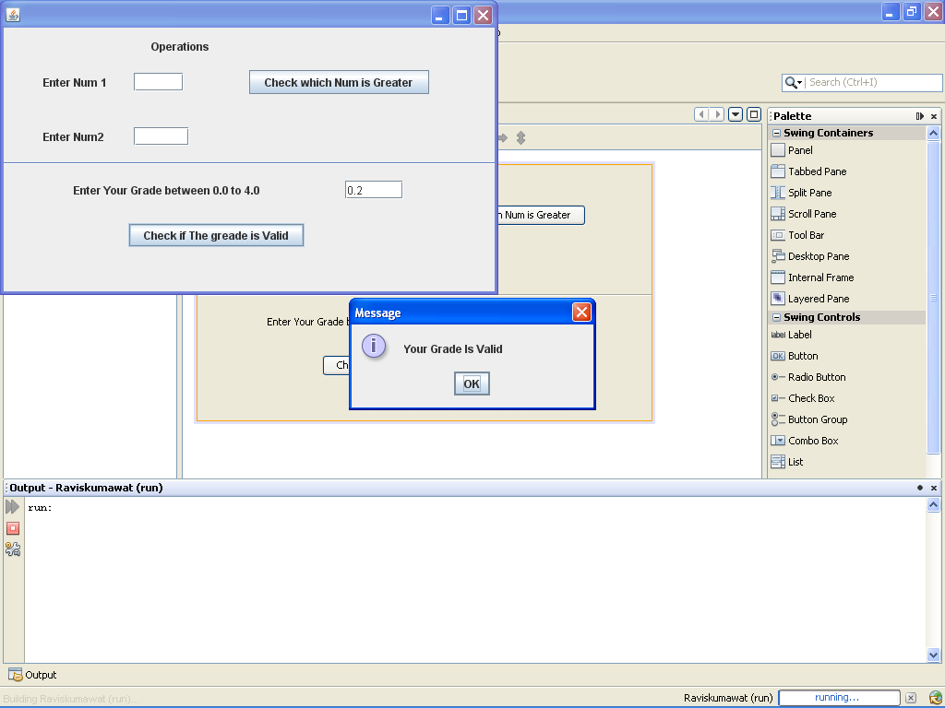

**Source code :-**

**For greater and less**

{ double num1=Double.parseDouble(jTextField1.getText());

double num2=Double.parseDouble(jTextField2.getText());

if (num1<num2)

{JOptionPane.showMessageDialog(null,"Second number is greater");}

else if (num1>num2)

{JOptionPane.showMessageDialog(null,"First number is greater");}

else

{JOptionPane.showMessageDialog(null,"Both are equal");}

}

**For checking Grade**

{ double g=Double.parseDouble(jTextField3.getText());

if ((g>0.0)&&(g<4.0))

{JOptionPane.showMessageDialog(null,"Your Grade Is Valid");}

else

{JOptionPane.showMessageDialog(null,"Your Grade Is Not Valid");}

}

**Q.write code to show first 15 natural numbers and their sum?**

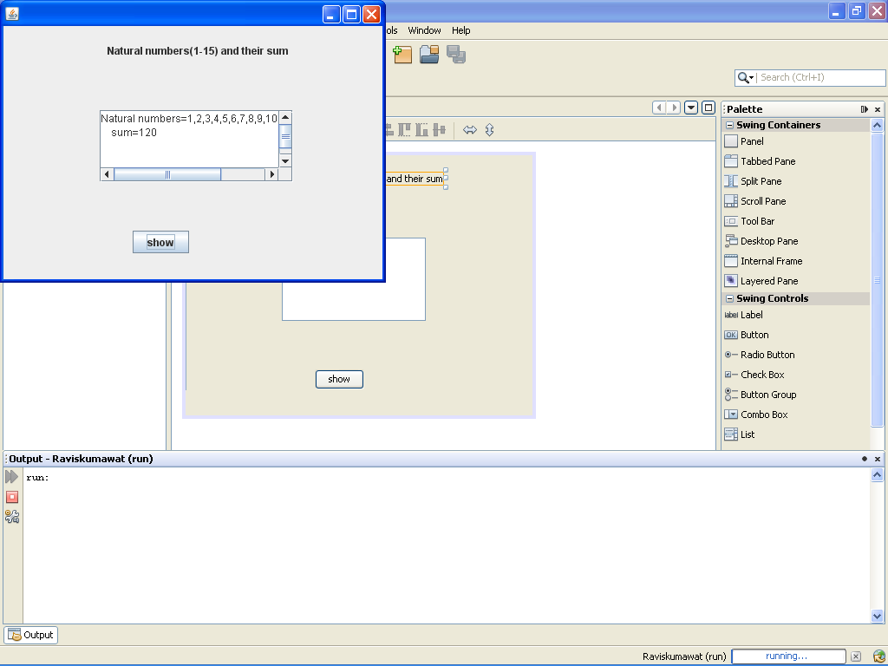

**Coding:-**

int sum=0;

for(int num=1;num<=15;num++)

{sum=sum+num;}

jTextArea1.setText("Natural numbers=1,2,3,4,5,6,7,8,9,10,11,12,13,14,15"+"\n sum="+sum);

**Q.write code to show first 15 natural numbers and their sum?**

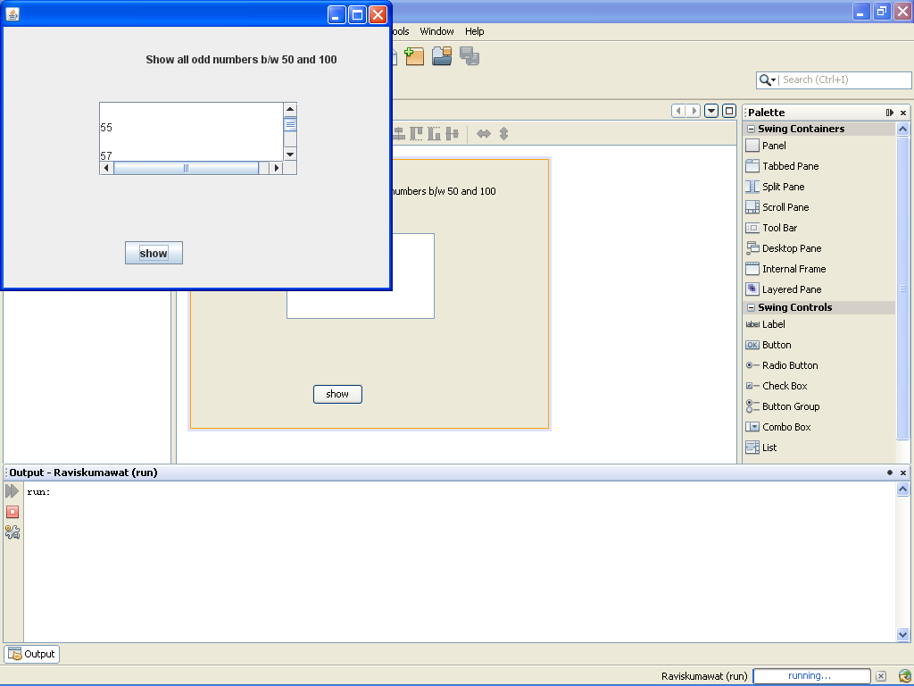

**Coding:-** int no=0,num;

for(num=50; num<=100;num++)

{if(num%2==0)

jTextArea1.append("\n");

else

jTextArea1.append("\n"+num); }

**Q.write the code to find the area ,perimeter,diagonal with lenth reducing with 2 every time?**

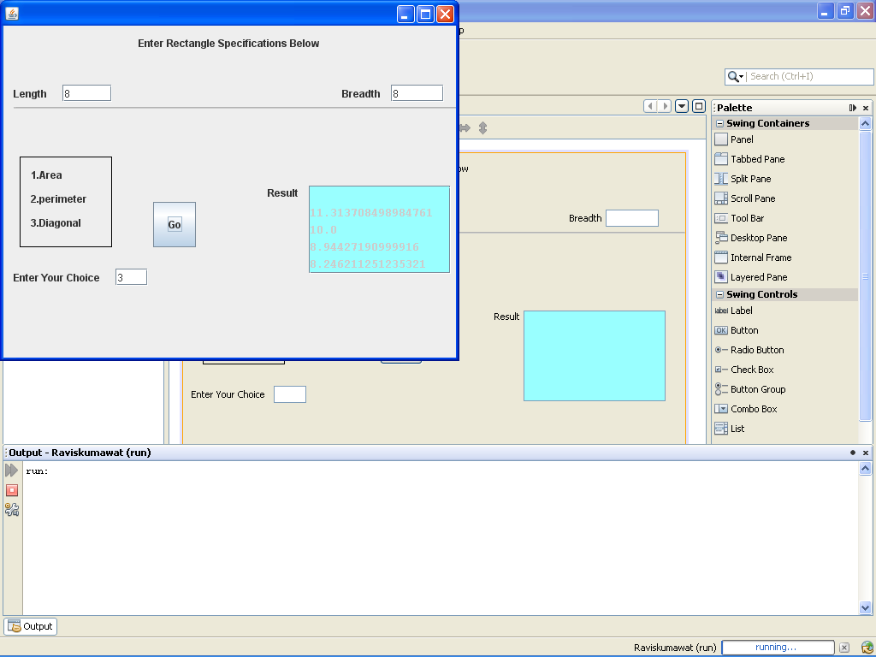

**Coding:-**

double r=0;

double l=Double.parseDouble(jTextField1.getText());

double b=Double.parseDouble(jTextField2.getText());

int c=Integer.parseInt(jTextField3.getText());

double a=l;

for(a=l;a>0;a=a-2)

if (c==1)

jTextArea1.append(""+"\n"+a*b);

else if (c==2)

jTextArea1.append("\n"+2*(a+b));

else

{ r=Math.sqrt((a*a)+(b*b));

jTextArea1.append("\n"+r);

}

**Q.write the code for sum of given series in Figure?**

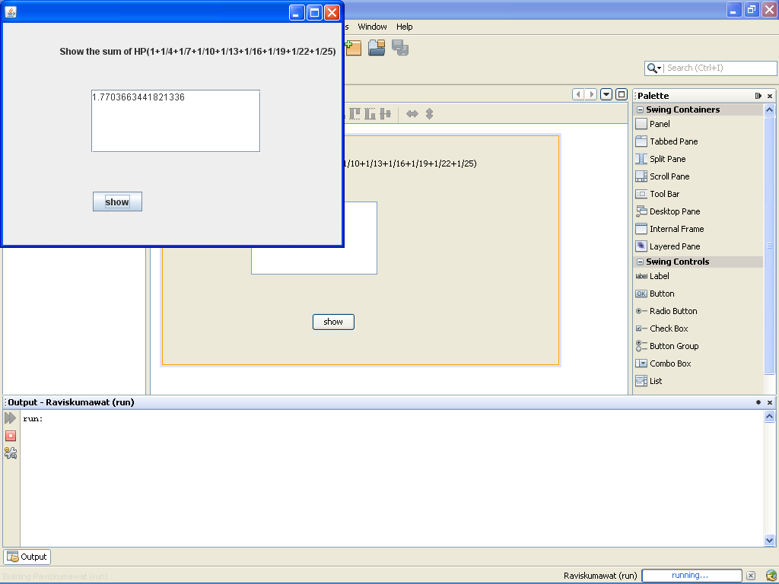

**Coding:-**

double x,sum=0,term;

for (x=1;x<=25;x+=3)

{term=1/x;

sum=sum+term;}

jTextArea1.setText(""+sum);

**Q.write the code for to show 10 stars in a line?**

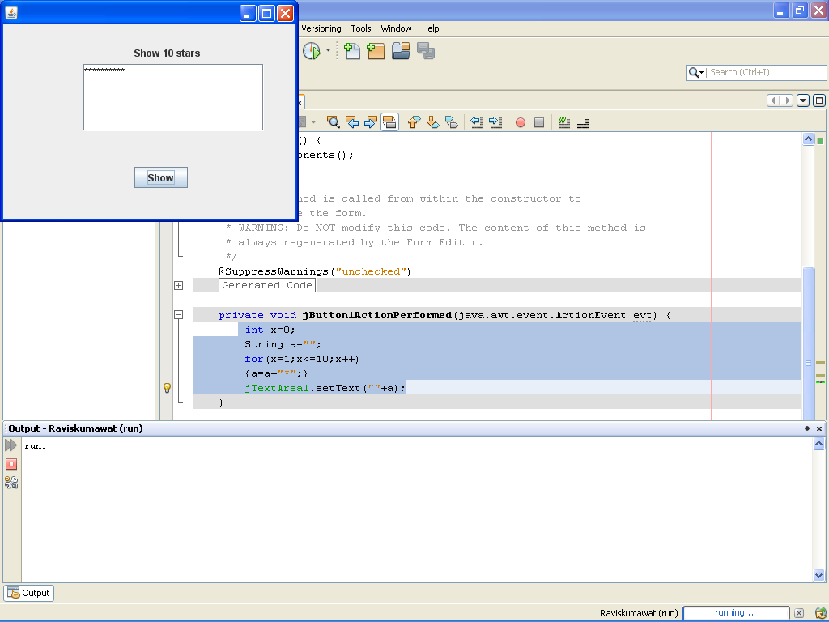

**Coding:-**

int x=0;

String a="";

for(x=1;x<=10;x++)

{a=a+"*";}

jTextArea1.setText(""+a);

**Q.write the code to show student result?**

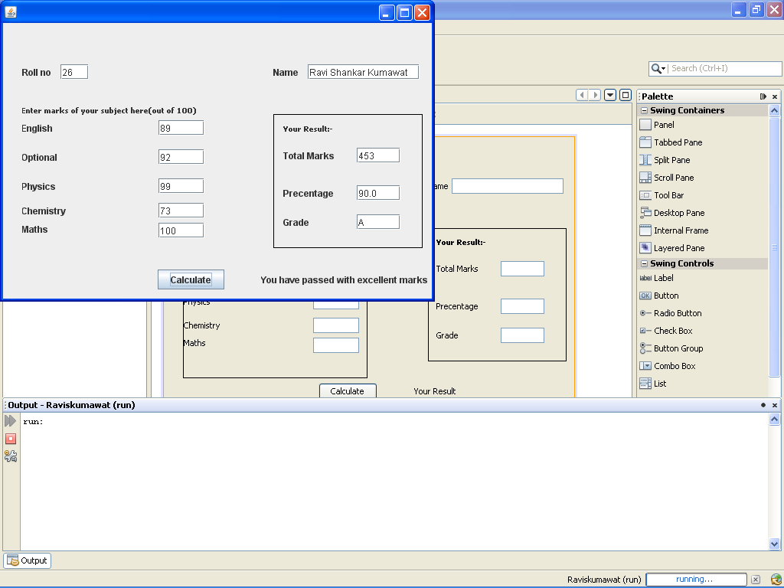

**Coding:-**

int eng=Integer.parseInt(jTextField3.getText());

int opt=Integer.parseInt(jTextField4.getText());

int phy=Integer.parseInt(jTextField5.getText());

int chem=Integer.parseInt(jTextField6.getText());

int math=Integer.parseInt(jTextField7.getText());

int gt=eng+opt+phy+chem+math;

jTextField8.setText(""+gt);

double per=gt*1/5;

jTextField9.setText(""+per);

if (per>=90)

{ jTextField10.setText("A");

jLabel13.setText("You have passed with excellent marks");

else if (per>=80&&per<90)

{ jTextField10.setText("B");

jLabel13.setText("You have passed with good marks"); }

else if (per>=70&&per<80)

{ jTextField10.setText("C");

jLabel13.setText("You have passed "); }

else if (per>=60&&per<70)

{jTextField10.setText("D");

jLabel13.setText("You have passed ");

}

else

{ jTextField10.setText("E");

jLabel13.setText("You have Failed"); }